RDKB RPI4 32b GW Build Sanity Test Results

- Flashed GW 32b dunfell build in rpi4
- Goto RG console

Summary Table
S.No | Sanity tested on | Status
1 | erouter0 interface got Wan IP | Pass
2 | brlan0 interface got default LAN IP | Pass
3 | Able to take SSH Connection | Pass
4 | All CCSP process are running | Pass
5 | Able to Ping www.google.com | Pass
6 | All systemd services are running | Pass
7 | Able to connect LAN client | Pass
8 | LAN client got IP from default pool range | Pass
9 | LAN client should open with CaptivePortal Page | Pass
10 | Able to connect wireless client | Pass
11 | Wireless client got IP from default pool range | Pass
12 | Wireless client can access the CaptivePortal Page | Pass
13 | Internet should work on Connected clients after changing the default credentials | Pass
14 | Using dmcli to check the CCSP TR-181 DataModels | Pass
15 | WebUI page should be loaded on Connected clients after changing the default credentials | Pass
16 | WebUI page should be loaded through erouter0IP via RM | Pass
17 | hostapd systemd service should be in running | Pass
18 | wlan0 and wlan1 interfaces should be UP and RUNNING | Pass
19 | All ccsp logs files should be generated in /rdklogs/logs folder | Pass

erouter0 IPv4 address
erouter0 should have valid IP based on the wan configuration
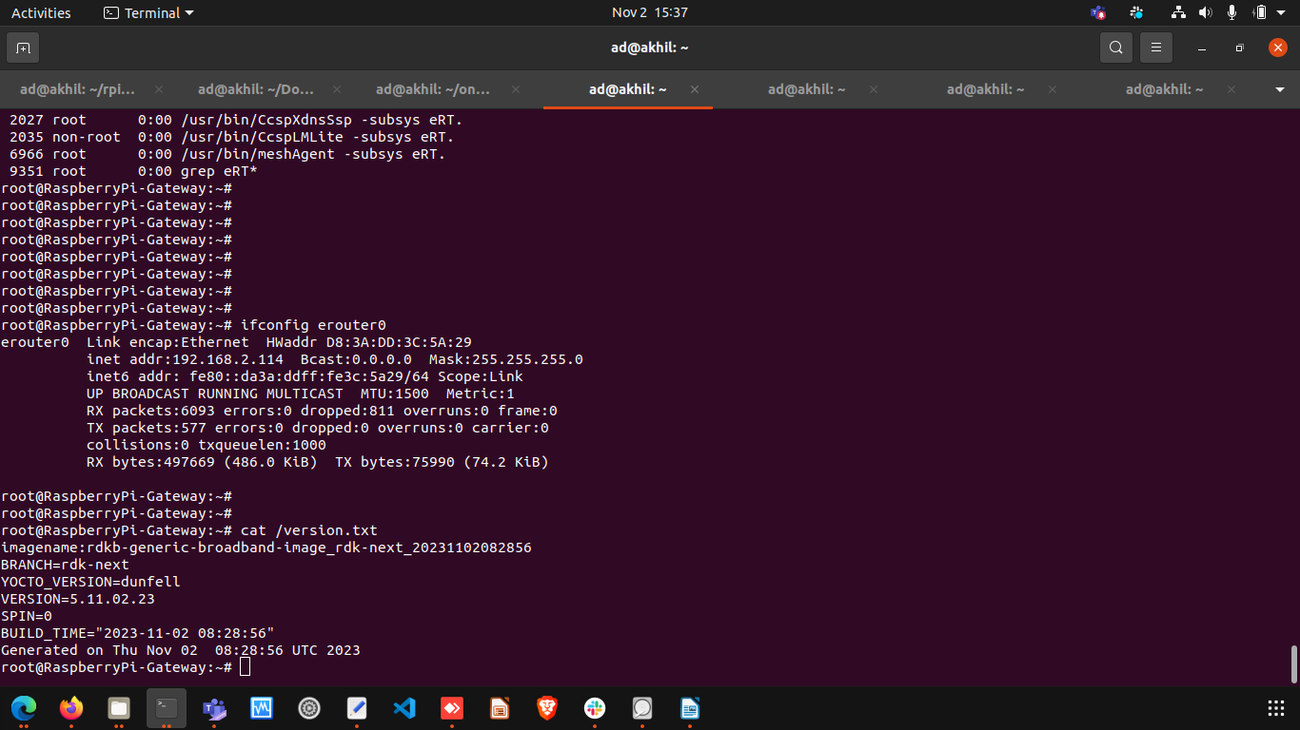
brlan0 IPv4 Address
brlan0 IPv4 should be 10.0.0.1 ( i,e Default IP Address )

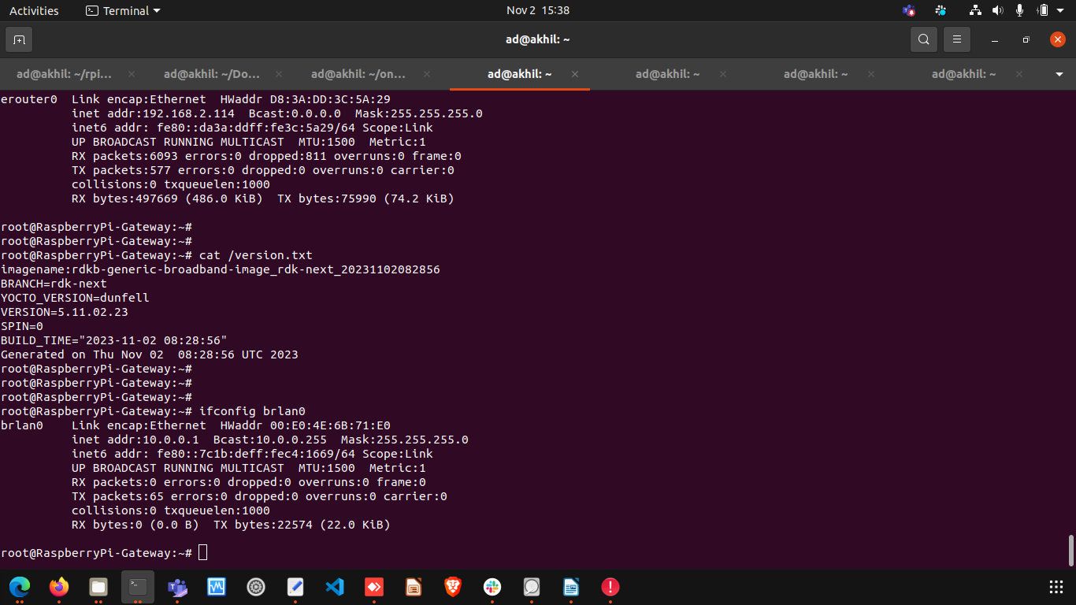

Able to take SSH from WAN IP
ssh from WAN to erouter0 IP should be successful
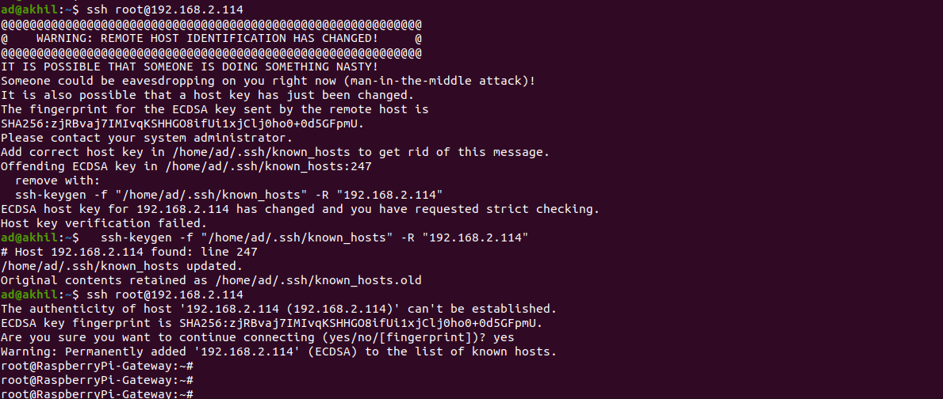

Internet Testing on RPI
- erouter0 Interface should have Ipv4 Address
- verify the ping www.google.com on RPI
- RPI shouldn't lose the Internet
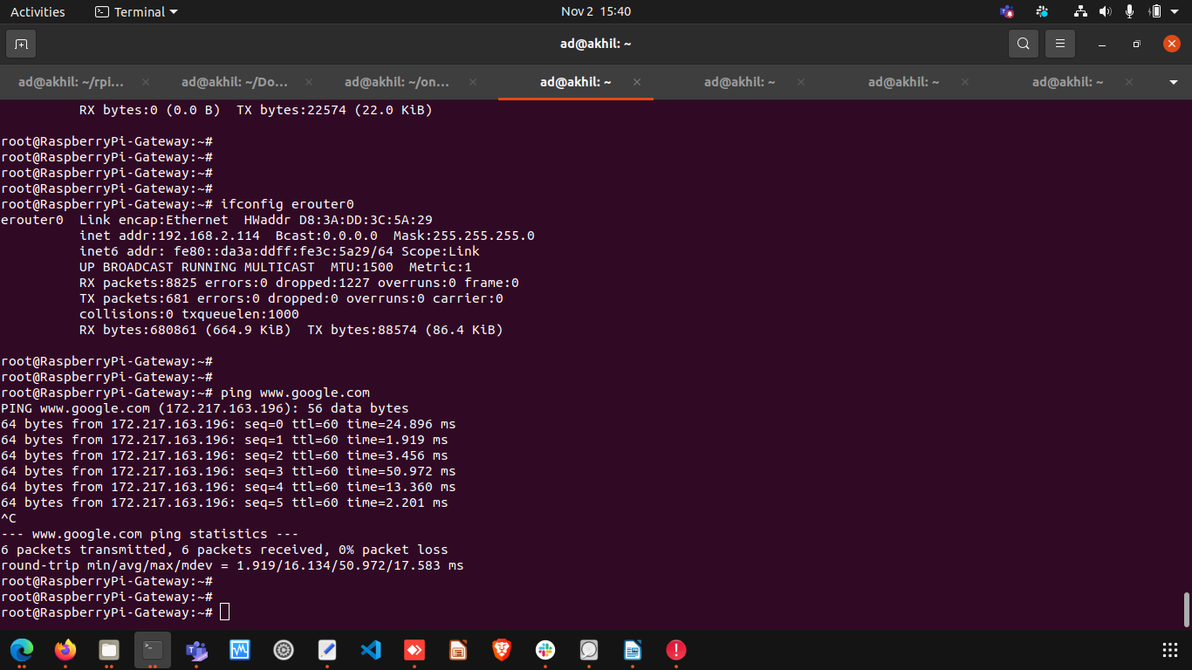
LAN client IPv4 and Internet
Lan clients should get IPv4 address in the range of 10 series(i,e default DHCP server pool range) and captive portal page should be loaded.
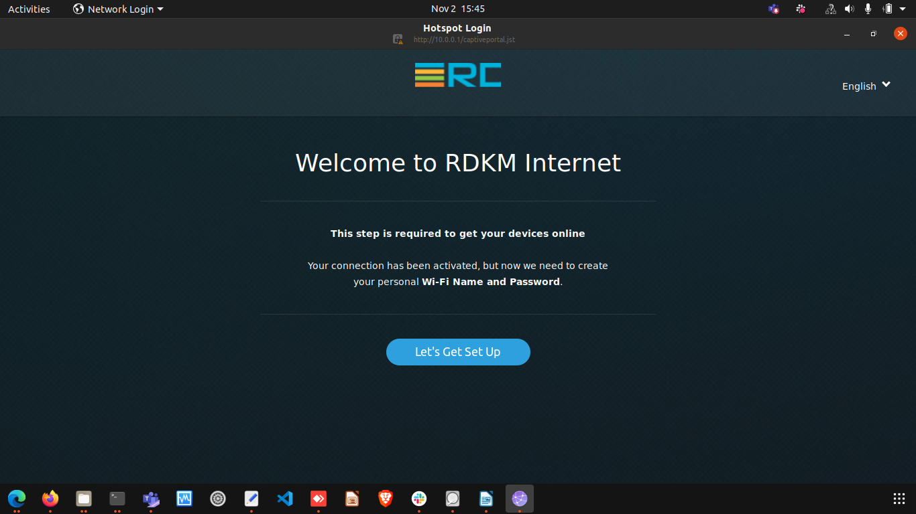
CCSP Process Status
All ccsp process should be Up and corresponding DataModel parameters should be loaded properly.
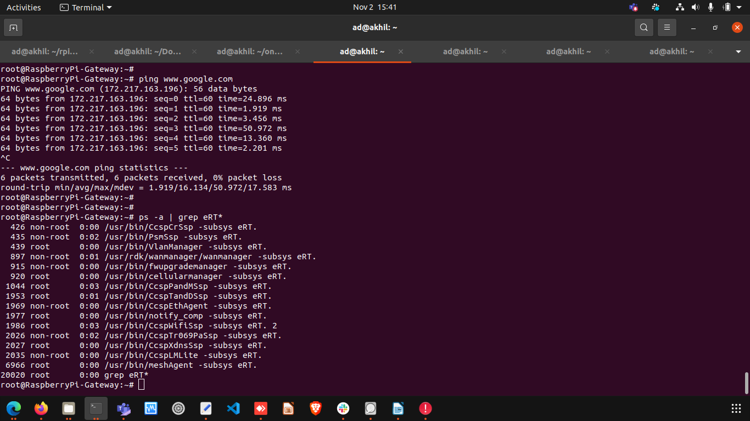
Logs
All ccsp logs will be generated in /rdklogs/logs folder
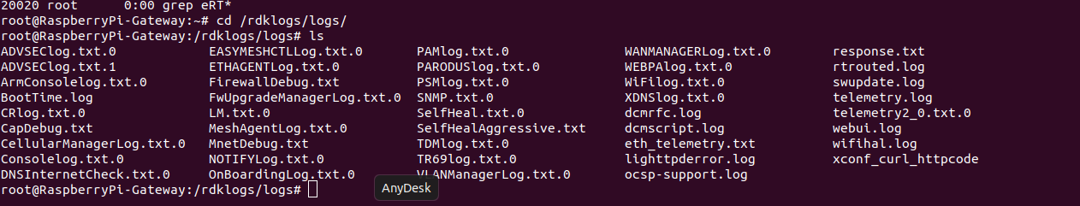
Systemd Status

root@RaspberryPi-Gateway:~# systemctl status
● RaspberryPi-Gateway
State: degraded
Jobs: 1 queued
Failed: 2 units
Since: Thu 1970-01-01 00:00:03 UTC; 53 years 10 months ago
CGroup: /
├─user.slice
│ └─user-0.slice
│ ├─session-c1.scope
│ │ ├─411 /bin/login -f
│ │ └─986 -sh
│ └─user@0.service …
│ └─init.scope
│ ├─887 /lib/systemd/systemd --user
│ └─889 (sd-pam)
├─init.scope
│ └─1 /sbin/init
└─system.slice
├─CcspTr069PaSsp.service
│ └─2026 /usr/bin/CcspTr069PaSsp -subsys eRT.
├─rbus_session_mgr.service
│ └─408 /usr/bin/rbus_session_mgr
├─notifyComp.service
│ └─1977 /usr/bin/notify_comp -subsys eRT.
├─CcspTandDSsp.service
│ ├─1953 /usr/bin/CcspTandDSsp -subsys eRT.
│ ├─2128 /bin/sh /usr/ccsp/tad/self_heal_connectivity_test.sh
│ ├─2132 /bin/sh /usr/ccsp/tad/resource_monitor.sh
│ ├─2425 sleep 2624
│ └─2477 sleep 900
├─CcspAdvSecuritySsp.service
│ └─21061 sleep 30
├─hostapd.service
│ └─3980 /usr/sbin/hostapd -g /var/run/hostapd/global -B -P /var/run/hostapd-global.pid
├─snmpSubAgent.service
│ └─1974 /usr/bin/snmp_subagent &
├─dbus.service
│ └─247 /usr/bin/dbus-daemon --system --address=systemd: --nofork --nopidfile --systemd-activation --syslog-only
├─rbus.service
│ └─283 /usr/bin/rtrouted
├─CcspXdnsSsp.service
│ └─2027 /usr/bin/CcspXdnsSsp -subsys eRT.
├─parodus.service
│ └─2460 /usr/bin/parodus --hw-model=RPI --hw-serial-number=10000000e57e4355 --hw-manufacturer=Raspberry --hw-last-reboot-reason=unknown --fw-name=rdkb-generic-broadband-image_rdk-next_20231102082856 --boot-time=1698829456 --hw-mac=D8:3A:DD:3C:5A:29 --webpa-ping-time=180 --webpa-interface-used=erouter0 --webpa-url=http://54.148.37.189:8080 --webpa-backoff-max=9 --parodus-local-url=tcp://127.0.0.1:6666 --partner-id=comcast --ssl-cert-path=/etc/ssl/certs/ca-certificates.crt --force-ipv4
├─utopia.service
│ ├─ 353 klogd -c 6
│ ├─ 356 syslogd -l 6
│ ├─ 383 syseventd
│ ├─ 402 /usr/bin/syseventd_fork_helper 12
│ ├─ 807 crond -l 9
│ ├─ 1128 trigger
│ ├─ 1293 dropbear -R -E -a -r /tmp/.dropbear/dropcfg11024 -r /tmp/.dropbear/dropcfg21024 -p []:22 -P /var/run/dropbear.pid -B
│ ├─ 1846 IGD brlan0
│ ├─ 3332 zebra -d -f /var/zebra.conf -P 0
│ ├─ 3366 nfq_handler 4
│ ├─ 4495 dnsmasq -P 4096 -C /var/dnsmasq.conf
│ ├─ 8753 dropbear -R -E -a -r /tmp/.dropbear/dropcfg11024 -r /tmp/.dropbear/dropcfg21024 -p []:22 -P /var/run/dropbear.pid -B
│ ├─ 8759 -sh
│ ├─21128 systemctl status
│ └─21129 /bin/cat
├─rbus_log.service
│ ├─ 405 /bin/sh /usr/bin/rbus_log_capture.sh
│ └─21065 sleep 10
├─system-getty.slice
│ └─getty@tty1.service
│ └─404 /sbin/agetty -o -p -- \u --noclear tty1 linux
├─RdkCellularManager.service
│ └─920 /usr/bin/cellularmanager -subsys eRT.
├─CcspLMLite.service
│ └─2035 /usr/bin/CcspLMLite -subsys eRT.
├─CcspPandMSsp.service
│ └─1044 /usr/bin/CcspPandMSsp -subsys eRT.
├─systemd-logind.service
│ └─307 /lib/systemd/systemd-logind
├─rdkbLogMonitor.service
│ ├─ 926 /bin/sh /rdklogger/rdkbLogMonitor.sh
│ └─20629 sleep 60
├─PsmSsp.service
│ └─435 /usr/bin/PsmSsp -subsys eRT.
├─systemd-udevd.service
│ └─184 /lib/systemd/systemd-udevd
├─webpabroadband.service
│ └─7186 /usr/bin/webpa &
├─CcspEthAgent.service
│ └─1969 /usr/bin/CcspEthAgent -subsys eRT.
├─busybox-syslog.service
│ └─246 /sbin/syslogd -n
├─dobby.service
│ └─257 /usr/sbin/DobbyDaemon --nofork --noconsole --journald
├─snmpd.service
│ └─284 /usr/sbin/snmpd -f -C -c /usr/ccsp/snmp/snmpd.conf -M /usr/share/snmp/mibs -Le
├─RdkWanManager.service
│ ├─ 897 /usr/rdk/wanmanager/wanmanager -subsys eRT.
│ ├─1075 netmonitor
│ └─3324 udhcpc -O 122 -i erouter0 -p /tmp/udhcpc.erouter0.pid -s /etc/udhcpc.script -R
├─systemd-journald.service
│ └─161 /lib/systemd/systemd-journald
├─busybox-klogd.service
│ └─245 /sbin/klogd -n
├─RdkFwUpgradeManager.service
│ └─915 /usr/bin/fwupgrademanager -subsys eRT.
├─ntpd.service
│ └─1964 /usr/sbin/ntpd -N -p 0.pool.ntp.org -p 1.pool.ntp.org -p 2.pool.ntp.org -p 3.pool.ntp.org
├─ccspwifiagent.service
│ ├─1986 /usr/bin/CcspWifiSsp -subsys eRT. 2
│ ├─6743 iw event -f
│ └─6754 iw event -f
├─usp-pa.service
│ └─3283 /usr/bin/UspPa -v1 --resetfile /etc/usp-pa/usp_factory_reset.conf --truststore /etc/usp-pa/usp_truststore.pem --interface erouter0 --log syslog --dbfile /nvram/usp-pa.db
├─meshAgent.service
│ └─6966 /usr/bin/meshAgent -subsys eRT.
├─CcspWebUI.service
│ ├─ 1952 /bin/sh /lib/rdk/brlan0_check.sh
│ ├─ 3898 lighttpd -f /etc/lighttpd.conf
│ └─21117 sleep 10
├─RdkVlanManager.service
│ └─439 /usr/bin/VlanManager -subsys eRT.
└─CcspCrSsp.service
└─426 /usr/bin/CcspCrSsp -subsys eRT.

WebUI Test on RPI
WebUI should be loaded in Webbrowser by using erouter0 IPv4 Address(i,e erouter0ip:80) and login should be successful
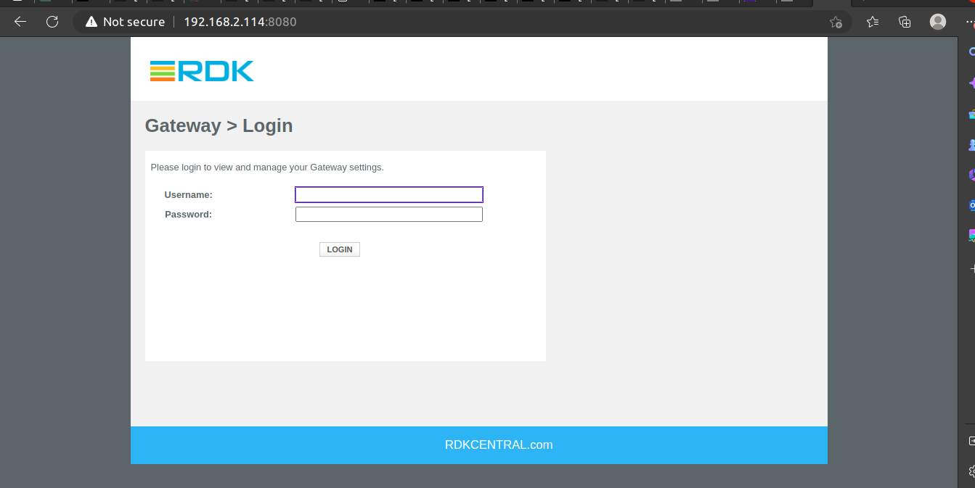

WiFi Status
root@RaspberryPi-Gateway:~# brctl show
bridge name bridge id STP enabled interfaces
br0 8000.000000000000 no
br106 8000.000000000000 no
br403 8000.000000000000 no
brebhaul 8000.000000000000 no
brlan0 8000.00e04e6b71e0 no eth1
wlan0
wlan1
brlan3 8000.9ea2f4d5ed96 no wlan2
root@RaspberryPi-Gateway:~# iw dev
phy#2
Interface wlan2
ifindex 11
wdev 0x200000001
addr 9e:a2:f4:d5:ed:96
type AP
txpower 12.00 dBm
phy#1
Interface wlan1
ifindex 10
wdev 0x100000001
addr 9c:a2:f4:d5:ed:96
ssid RPi3_RDKB-AP1
type AP
txpower 12.00 dBm
phy#0
Interface wlan0
ifindex 9
wdev 0x1
addr d8:3a:dd:3c:5a:2b
ssid RPi3_RDKB-AP0
type AP
channel 6 (2437 MHz), width: 20 MHz, center1: 2437 MHz
txpower 31.00 dBm

