RDKB RPI4 32b dunfell GW Build Sanity Test Results

- Flashed GW 32b dunfell build in rpi4
- Goto RG console

Summary Table
S.No | Sanity tested on | Status
1 | erouter0 interface got Wan IP | Pass
2 | brlan0 interface got default LAN IP | Pass
3 | Able to take SSH Connection | Pass
4 | All CCSP process are running | Pass
5 | Able to Ping www.google.com | Pass
6 | All systemd services are running | Pass
7 | Able to connect wireless client | Pass
8 | Wireless client got IP from default pool range | Pass
9 | Wireless client can access the CaptivePortal Page | Pass
10 | Internet should work on Connected clients after changing the default credentials | Pass
11 | Using dmcli to check the CCSP TR-181 DataModels | Pass
12 | WebUI page should be loaded on Connected clients after changing the default credentials | Pass
13 | WebUI page should be loaded through erouter0IP via RM | Pass
14 | wlan0 and wlan1 interfaces should be UP and RUNNING | Pass
15 | All ccsp logs files should be generated in /rdklogs/logs folder | Pass

erouter0 IPv4 address
erouter0 should have valid IP based on the wan configuration .
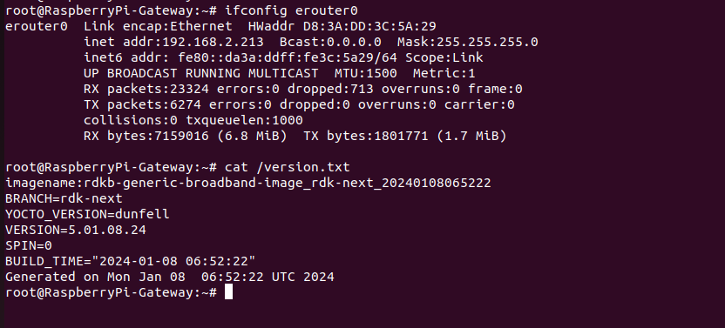
brlan0 IPv4 address
brlan0 IPv4 should be 10.0.0.1 ( i,e Default IP Address )
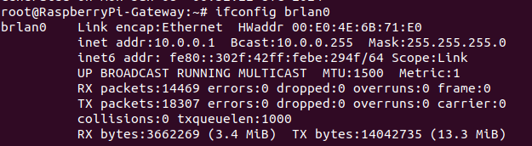
Able to take SSH from WAN IP
ssh from WAN to erouter0 IP should be successful
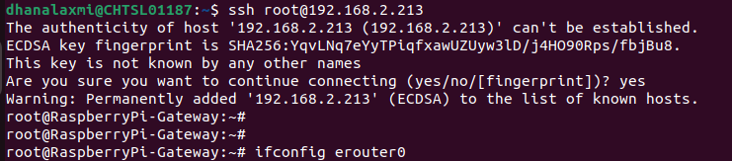

Internet Testing on RPI
- erouter0 Interface should have Ipv4 Address
- verify the ping www.google.com on RPI
- RPI shouldn't lose the Internet
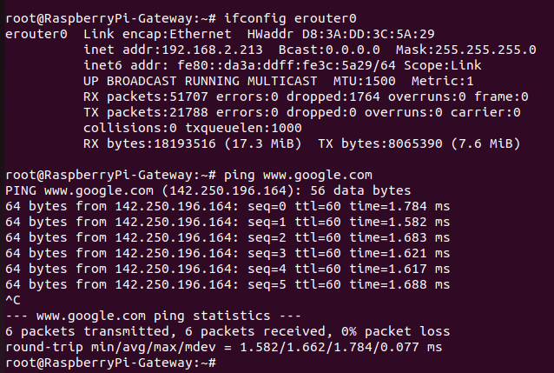
CCSP Process Status
All ccsp process should be Up and corresponding DataModel parameters should be loaded properly.
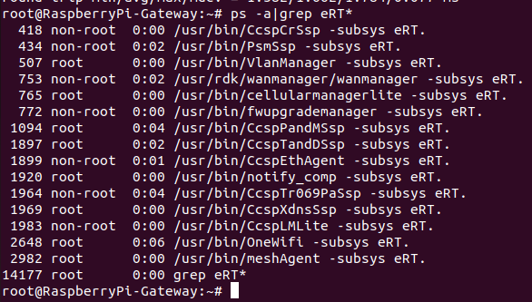
Logs
All ccsp logs will be generated in /rdklogs/logs folder
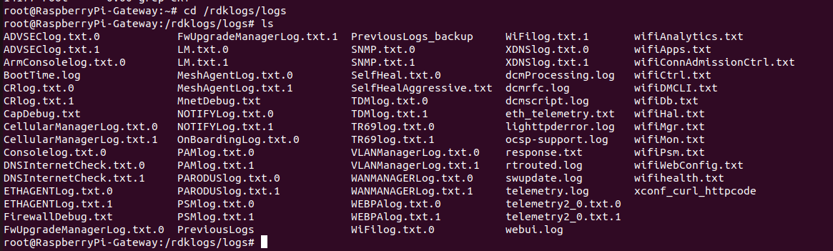

Systemd Status
root@RaspberryPi-Gateway:~# systemctl status
● RaspberryPi-Gateway
State: degraded
Jobs: 0 queued
Failed: 1 units
Since: Thu 1970-01-01 00:00:03 UTC; 54 years 0 months ago
CGroup: /
├─user.slice
│ └─user-0.slice
│ ├─session-c1.scope
│ │ ├─ 401 /bin/login -f
│ │ └─1013 -sh
│ └─user@0.service …
│ └─init.scope
│ ├─927 /lib/systemd/systemd --user
│ └─928 (sd-pam)
├─init.scope
│ └─1 /sbin/init
└─system.slice
├─CcspTr069PaSsp.service
│ └─1964 /usr/bin/CcspTr069PaSsp -subsys eRT.
├─rbus_session_mgr.service
│ └─397 /usr/bin/rbus_session_mgr
├─notifyComp.service
│ └─1920 /usr/bin/notify_comp -subsys eRT.
├─CcspTandDSsp.service
│ ├─1897 /usr/bin/CcspTandDSsp -subsys eRT.
│ ├─2090 /bin/sh /usr/ccsp/tad/self_heal_connectivity_test.sh
│ ├─2092 /bin/sh /usr/ccsp/tad/resource_monitor.sh
│ ├─2358 sleep 3551
│ └─5778 sleep 900
├─CcspAdvSecuritySsp.service
│ └─17718 /usr/bin/CcspAdvSecuritySsp -subsys eRT.
├─snmpSubAgent.service
│ └─1921 /usr/bin/snmp_subagent &
├─dbus.service
│ └─238 /usr/bin/dbus-daemon --system --address=systemd: --nofork --nopidfile --systemd-activation --syslog-only
├─rbus.service
│ └─274 /usr/bin/rtrouted
├─dsm.service
│ └─383 /usr/bin/dsm
├─CcspXdnsSsp.service
│ └─1969 /usr/bin/CcspXdnsSsp -subsys eRT.
├─parodus.service
│ └─2374 /usr/bin/parodus --hw-model=RPI --hw-serial-number=10000000e57e4355 --hw-manufacturer=Raspberry --hw-last-reboot-reason=unknown --fw-name=rdkb-generic-broadband-image_rdk-next_20240108065222 --boot-time=1704696850 --hw-mac=D8:3A:DD:3C:5A:29 --webpa-ping-time=180 --webpa-interface-used=erouter0 --webpa-url=http://52.88.248.43:8080 --webpa-backoff-max=9 --parodus-local-url=tcp://127.0.0.1:6666 --partner-id=comcast --ssl-cert-path=/etc/ssl/certs/ca-certificates.crt --force-ipv4
├─utopia.service
│ ├─ 338 klogd -c 6
│ ├─ 341 syslogd -l 6
│ ├─ 362 syseventd
│ ├─ 378 /usr/bin/syseventd_fork_helper 12
│ ├─ 644 crond -l 9
│ ├─ 966 trigger
│ ├─ 1174 dropbear -R -E -a -r /tmp/.dropbear/dropcfg1914 -r /tmp/.dropbear/dropcfg2914 -p []:22 -P /var/run/dropbear.pid -B
│ ├─ 1771 IGD brlan0
│ ├─ 2594 dnsmasq -P 4096 -C /var/dnsmasq.conf
│ ├─ 2925 zebra -d -f /var/zebra.conf -P 0
│ ├─ 2979 nfq_handler 4
│ ├─12774 sh /lib/rdk/dcaSplunkUpload.sh
│ ├─16304 dropbear -R -E -a -r /tmp/.dropbear/dropcfg1914 -r /tmp/.dropbear/dropcfg2914 -p []:22 -P /var/run/dropbear.pid -B
│ ├─16390 -sh
│ ├─18055 sh /lib/rdk/dcaSplunkUpload.sh
│ ├─18056 curl --tlsv1.2 -w %{http_code}\n -H Accept: application/json -H Content-type: application/json -X POST -d @/nvram/rtl_json.txt http://52.0.158.162:8080/telemetry-collector/rdkb-collector --connect-timeout 30 -m 30
│ ├─18170 systemctl status
│ ├─18171 /bin/cat
│ ├─24445 dropbear -R -E -a -r /tmp/.dropbear/dropcfg1914 -r /tmp/.dropbear/dropcfg2914 -p []:22 -P /var/run/dropbear.pid -B
│ └─24466 -sh
├─CcspTelemetry.service
│ └─2547 /usr/bin/telemetry2_0
├─rbus_log.service
│ ├─ 392 /bin/sh /usr/bin/rbus_log_capture.sh
│ └─18093 sleep 10
├─system-getty.slice
│ └─getty@tty1.service
│ └─384 /sbin/agetty -o -p -- \u --noclear tty1 linux
├─CcspLMLite.service
│ └─1983 /usr/bin/CcspLMLite -subsys eRT.
├─CcspPandMSsp.service
│ └─1094 /usr/bin/CcspPandMSsp -subsys eRT.
├─systemd-logind.service
│ └─296 /lib/systemd/systemd-logind
├─rdkbLogMonitor.service
│ ├─ 958 /bin/sh /rdklogger/rdkbLogMonitor.sh
│ └─17600 sleep 60
├─RdkCellularManagerLite.service
│ └─765 /usr/bin/cellularmanagerlite -subsys eRT.
├─PsmSsp.service
│ └─434 /usr/bin/PsmSsp -subsys eRT.
├─systemd-udevd.service
│ └─180 /lib/systemd/systemd-udevd
├─webpabroadband.service
│ └─2663 /usr/bin/webpa &
├─CcspEthAgent.service
│ └─1899 /usr/bin/CcspEthAgent -subsys eRT.
├─busybox-syslog.service
│ └─237 /sbin/syslogd -n
├─dobby.service
│ └─247 /usr/sbin/DobbyDaemon --nofork --noconsole --journald
├─snmpd.service
│ └─275 /usr/sbin/snmpd -f -C -c /usr/ccsp/snmp/snmpd.conf -M /usr/share/snmp/mibs -Le
├─RdkWanManager.service
│ ├─ 753 /usr/rdk/wanmanager/wanmanager -subsys eRT.
│ ├─ 913 netmonitor
│ └─2997 udhcpc -i erouter0 -p /tmp/udhcpc.erouter0.pid -s /etc/udhcpc.script
├─systemd-journald.service
│ └─160 /lib/systemd/systemd-journald
├─busybox-klogd.service
│ └─236 /sbin/klogd -n
├─RdkFwUpgradeManager.service
│ └─772 /usr/bin/fwupgrademanager -subsys eRT.
├─ntpd.service
│ └─1916 /usr/sbin/ntpd -N -p 0.pool.ntp.org -p 1.pool.ntp.org -p 2.pool.ntp.org -p 3.pool.ntp.org
├─onewifi.service
│ ├─2648 /usr/bin/OneWifi -subsys eRT.
│ └─2679 /var/tmp/wifidb-server /opt/secure/wifi/rdkb-wifi.db --remote=punix:/var/tmp/wifidb.sock --unixctl=/var/tmp/wifi.ctl --log-file=/dev/null --detach
├─usp-pa.service
│ └─2916 /usr/bin/UspPa -v1 --resetfile /etc/usp-pa/usp_factory_reset.conf --truststore /etc/usp-pa/usp_truststore.pem --interface erouter0 --log syslog --dbfile /nvram/usp-pa.db
├─meshAgent.service
│ └─2982 /usr/bin/meshAgent -subsys eRT.
├─CcspWebUI.service
│ ├─ 1908 /bin/sh /lib/rdk/brlan0_check.sh
│ ├─ 3385 lighttpd -f /etc/lighttpd.conf
│ └─18169 sleep 10
├─RdkVlanManager.service
│ └─507 /usr/bin/VlanManager -subsys eRT.
└─CcspCrSsp.service
└─418 /usr/bin/CcspCrSsp -subsys eRT.

WebUI Test on RPI
WebUI should be loaded in Webbrowser by using erouter0 IPv4 Address(i,e erouter0ip:80) and login should be successful
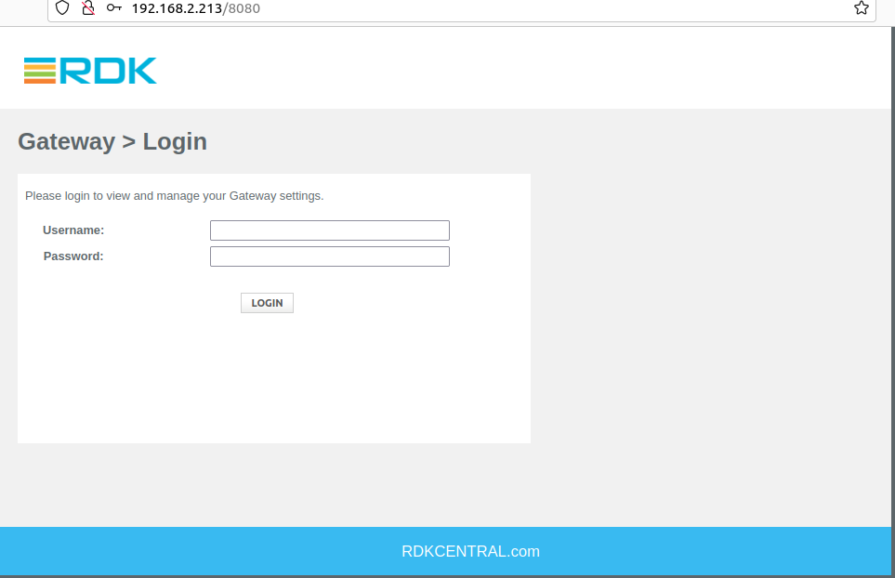

WiFi Status
root@RaspberryPi-Gateway:~# brctl show
bridge name bridge id STP enabled interfaces
br0 8000.000000000000 no
br106 8000.000000000000 no
br403 8000.000000000000 no
brebhaul 8000.000000000000 no
brlan0 8000.00e04e6b71e0 no eth1
wlan0
wlan1
root@RaspberryPi-Gateway:~# iw dev
phy#2
Interface wlan2
ifindex 19
wdev 0x200000001
addr 1e:61:b4:36:d6:ed
type managed
txpower 12.00 dBm
phy#1
Interface wlan1
ifindex 18
wdev 0x100000001
addr 1c:61:b4:36:d6:ed
ssid RPI_RDKB-AP1
type AP
txpower 12.00 dBm
phy#0
Interface wlan0
ifindex 17
wdev 0x1
addr d8:3a:dd:3c:5a:2b
ssid RPI_RDKB-AP0
type AP
channel 1 (2412 MHz), width: 20 MHz, center1: 2412 MHz
txpower 31.00 dBm
Captive Portal
