RDKB RPI4 32b kirkstone GW Build Sanity Test Results

- Flashed GW 32b kirkstone build in rpi4
- Goto RG console

Summary Table
S.No | Sanity tested on | Status
1 | erouter0 interface got Wan IP | Pass
2 | brlan0 interface got default LAN IP | Pass
3 | Able to take SSH Connection | Pass
4 | All CCSP process are running | Pass
5 | Able to Ping www.google.com | Pass
6 | All systemd services are running | Pass
7 | Able to connect wireless client | Pass
8 | Wireless client got IP from default pool range | Pass
9 | Wireless client can access the CaptivePortal Page | Pass
10 | Internet should work on Connected clients after changing the default credentials | Pass
11 | Using dmcli to check the CCSP TR-181 DataModels | Pass
12 | WebUI page should be loaded on Connected clients after changing the default credentials | Pass
13 | WebUI page should be loaded through erouter0IP via RM | Pass
14 | wlan0 and wlan1 interfaces should be UP and RUNNING | Pass
15 | All ccsp logs files should be generated in /rdklogs/logs folder | Pass
16 | Lan clients should be connected and receive internet | Pass

erouter0 IPv4 address
erouter0 should have valid IP based on the wan configuration .
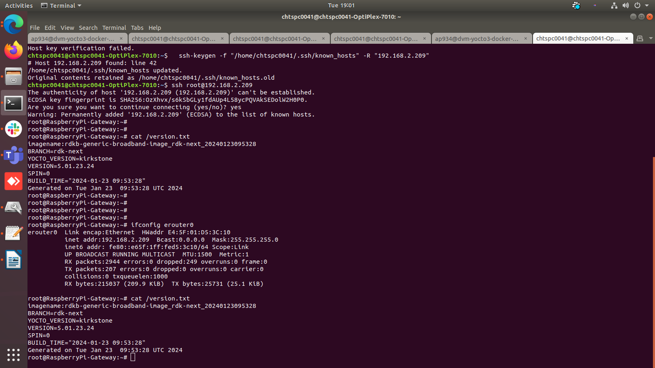
brlan0 IPv4 address
brlan0 IPv4 should be 10.0.0.1 ( i,e Default IP Address )
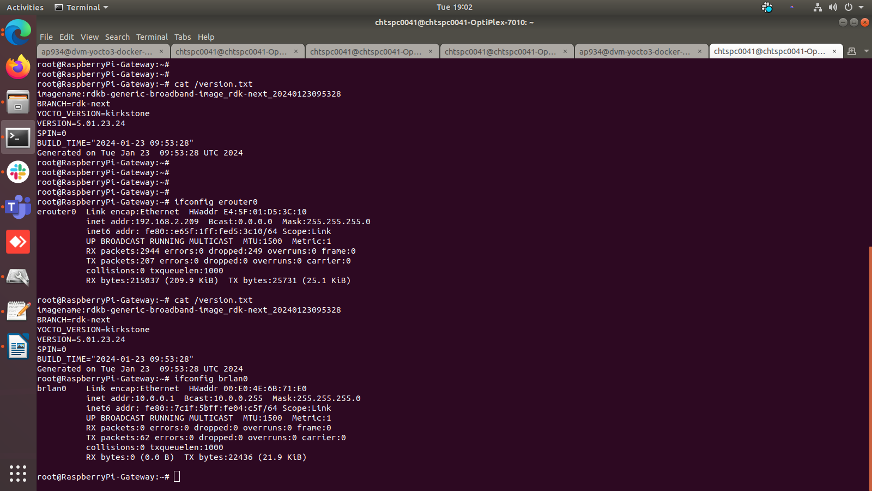
Able to take SSH from WAN IP
ssh from WAN to erouter0 IP should be successful
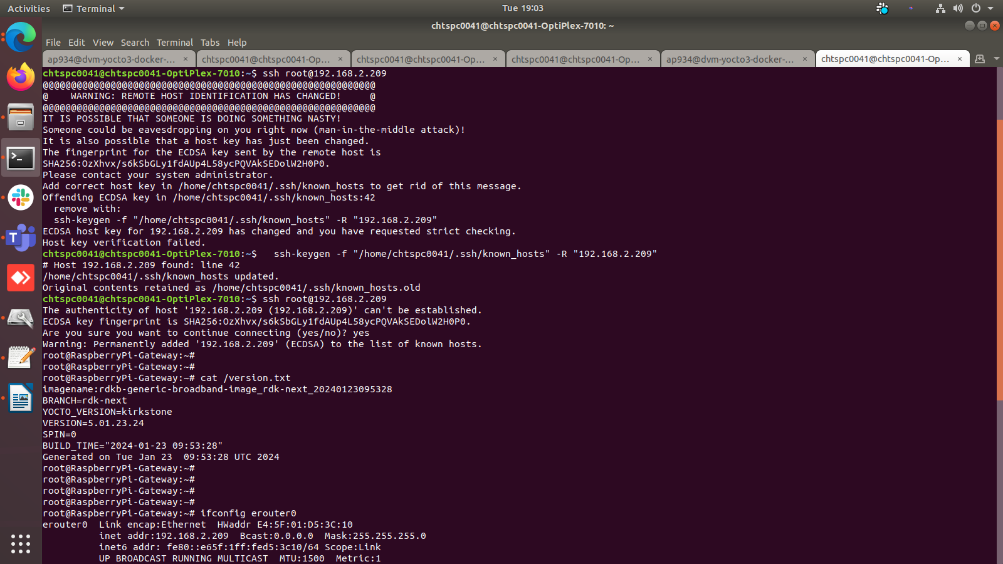

Internet Testing on RPI
- erouter0 Interface should have Ipv4 Address
- verify the ping www.google.com on RPI
- RPI shouldn't lose the Internet
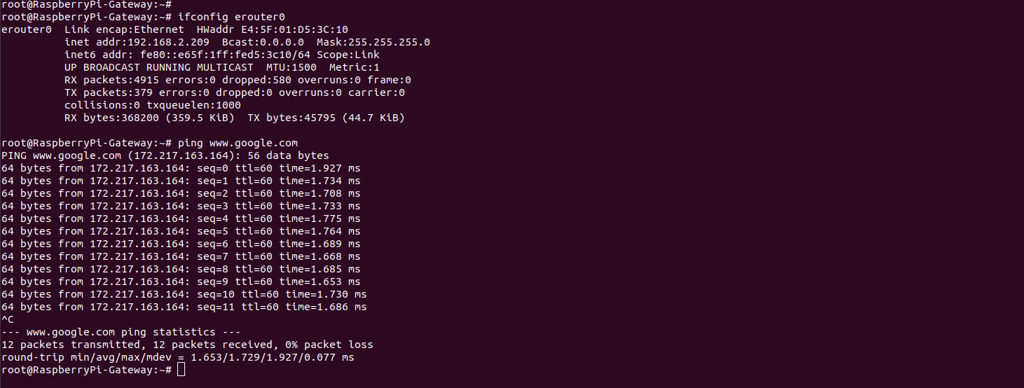
CCSP Process Status
All ccsp process should be Up and corresponding DataModel parameters should be loaded properly.
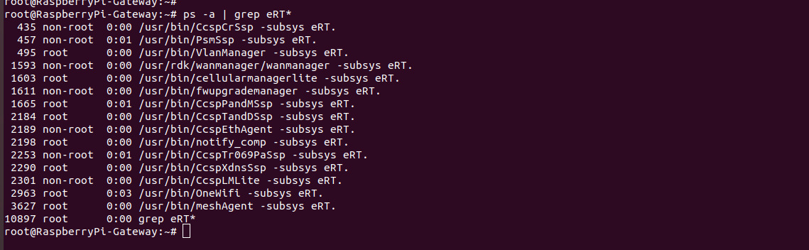
Logs
All ccsp logs will be generated in /rdklogs/logs folder
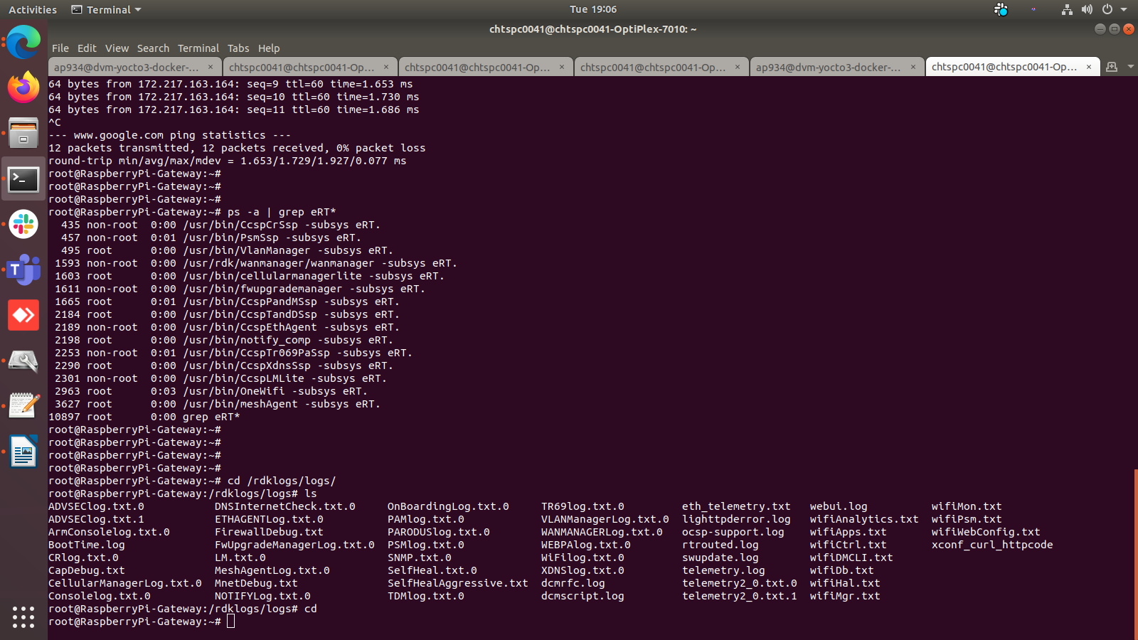

Systemd Status
root@RaspberryPi-Gateway:~# systemctl status
● RaspberryPi-Gateway
State: degraded
Jobs: 0 queued
Failed: 1 units
Since: Thu 1970-01-01 00:00:03 UTC; 54 years 0 months ago
CGroup: /
├─init.scope
│ └─ 1 /sbin/init
└─system.slice
├─CcspAdvSecuritySsp.service
│ └─ 12239 /usr/bin/CcspAdvSecuritySsp -subsys eRT.
├─CcspCrSsp.service
│ └─ 435 /usr/bin/CcspCrSsp -subsys eRT.
├─CcspEthAgent.service
│ └─ 2189 /usr/bin/CcspEthAgent -subsys eRT.
├─CcspLMLite.service
│ └─ 2301 /usr/bin/CcspLMLite -subsys eRT.
├─CcspPandMSsp.service
│ └─ 1665 /usr/bin/CcspPandMSsp -subsys eRT.
├─CcspTandDSsp.service
│ ├─ 2184 /usr/bin/CcspTandDSsp -subsys eRT.
│ ├─ 2431 /bin/sh /usr/ccsp/tad/self_heal_connectivity_test.sh
│ ├─ 2434 /bin/sh /usr/ccsp/tad/resource_monitor.sh
│ ├─ 2611 sleep 2409
│ └─ 2703 sleep 900
├─CcspTelemetry.service
│ ├─ 2596 /bin/sh /lib/rdk/StartDCM.sh
│ ├─ 2845 /usr/bin/telemetry2_0
│ └─ 12462 sleep 5
├─CcspTr069PaSsp.service
│ └─ 2253 /usr/bin/CcspTr069PaSsp -subsys eRT.
├─CcspWebUI.service
│ ├─ 2177 /bin/sh /lib/rdk/brlan0_check.sh
│ ├─ 4085 lighttpd -f /etc/lighttpd.conf
│ └─ 12460 sleep 10
├─CcspXdnsSsp.service
│ └─ 2290 /usr/bin/CcspXdnsSsp -subsys eRT.
├─PsmSsp.service
│ └─ 457 /usr/bin/PsmSsp -subsys eRT.
├─RdkCellularManagerLite.service
│ └─ 1603 /usr/bin/cellularmanagerlite -subsys eRT.
├─RdkFwUpgradeManager.service
│ └─ 1611 /usr/bin/fwupgrademanager -subsys eRT.
├─RdkVlanManager.service
│ └─ 495 /usr/bin/VlanManager -subsys eRT.
├─RdkWanManager.service
│ ├─ 1593 /usr/rdk/wanmanager/wanmanager -subsys eRT.
│ ├─ 1720 netmonitor
│ └─ 3389 udhcpc -i erouter0 -p /tmp/udhcpc.erouter0.pid -s /etc/udhcpc.script
├─busybox-klogd.service
│ └─ 259 /sbin/klogd -n
├─busybox-syslog.service
│ └─ 260 /sbin/syslogd -n
├─dbus.service
│ └─ 261 /usr/bin/dbus-daemon --system --address=systemd: --nofork --nopidfile --systemd-activation --syslog-only
├─dobby.service
│ └─ 405 /usr/sbin/DobbyDaemon --nofork --noconsole --journald
├─dsm.service
│ └─ 425 /usr/bin/dsm
├─meshAgent.service
│ └─ 3627 /usr/bin/meshAgent -subsys eRT.
├─notifyComp.service
│ └─ 2198 /usr/bin/notify_comp -subsys eRT.
├─ntpd.service
│ └─ 2180 /usr/sbin/ntpd -N -p 0.pool.ntp.org -p 1.pool.ntp.org -p 2.pool.ntp.org -p 3.pool.ntp.org
├─onewifi.service
│ ├─ 2963 /usr/bin/OneWifi -subsys eRT.
│ └─ 3068 /var/tmp/wifidb-server /opt/secure/wifi/rdkb-wifi.db --remote=punix:/var/tmp/wifidb.sock --unixctl=/var/tmp/wifi.ctl --log-file=/dev/null --detach
├─parodus.service
│ └─ 2613 /usr/bin/parodus --hw-model=RPI --hw-serial-number=100000007fe11c07 --hw-manufacturer=Raspberry --hw-last-reboot-reason=unknown --fw-name=rdkb-generic-broadband-image_rdk-next_20240123095328 --boot-time=1651167741 --hw-mac=E4:5F:01:D5:3C:10 --webpa-ping-time=180 --webpa-interface-used=erouter0 --webpa-url=http://52.88.248.43:8080 --webpa-backoff-max=9 --parodus-local-url=tcp://127.0.0.1:6666 --partner-id=comcast --ssl-cert-path=/etc/ssl/certs/ca-certificates.crt --force-ipv4
├─rbus.service
│ └─ 291 /usr/bin/rtrouted
├─rbus_log.service
│ ├─ 406 /bin/sh /usr/bin/rbus_log_capture.sh
│ └─ 12344 sleep 10
├─rbus_session_mgr.service
│ └─ 418 /usr/bin/rbus_session_mgr
├─rdkbLogMonitor.service
│ ├─ 939 /bin/sh /rdklogger/rdkbLogMonitor.sh
│ └─ 12480 sleep 60
├─snmpSubAgent.service
│ └─ 2194 /usr/bin/snmp_subagent "&"
├─snmpd.service
│ └─ 293 /usr/sbin/snmpd -f -C -c /usr/ccsp/snmp/snmpd.conf -M /usr/share/snmp/mibs -Le
├─system-getty.slice
│ └─getty@tty1.service
│ └─ 273 /sbin/agetty -o "-p -- \\u" --noclear - linux
├─system-serial\x2dgetty.slice
│ └─serial-getty@ttyS0.service
│ ├─ 292 /bin/login -f
│ └─ 633 -sh
├─systemd-journald.service
│ └─ 164 /lib/systemd/systemd-journald
├─systemd-udevd.service
│ └─ 185 /lib/systemd/systemd-udevd
├─usp-pa.service
│ └─ 3300 /usr/bin/UspPa -v1 --resetfile /etc/usp-pa/usp_factory_reset.conf --truststore /etc/usp-pa/usp_truststore.pem --interface erouter0 --log syslog --dbfile /nvram/usp-pa.db
├─utopia.service
│ ├─ 354 klogd -c 6
│ ├─ 357 syslogd -l 6
│ ├─ 384 syseventd
│ ├─ 400 /usr/bin/syseventd_fork_helper 12
│ ├─ 801 crond -l 9
│ ├─ 1074 trigger
│ ├─ 1244 dropbear -R -E -a -r /tmp/.dropbear/dropcfg11004 -r /tmp/.dropbear/dropcfg21004 -p "[]:22" -P /var/run/dropbear.pid -B
│ ├─ 1676 IGD brlan0
│ ├─ 3423 zebra -d -f /var/zebra.conf -P 0
│ ├─ 3445 nfq_handler 4
│ ├─ 4547 dnsmasq -P 4096 -C /var/dnsmasq.conf
│ ├─ 5222 dropbear -R -E -a -r /tmp/.dropbear/dropcfg11004 -r /tmp/.dropbear/dropcfg21004 -p "[]:22" -P /var/run/dropbear.pid -B
│ ├─ 5241 -sh
│ ├─ 12481 systemctl status
│ └─ 12482 /bin/cat
└─webpabroadband.service
└─ 3012 /usr/bin/webpa "&"

WebUI Test on RPI
WebUI should be loaded in Webbrowser by using erouter0 IPv4 Address(i,e erouter0ip:80) and login should be successful

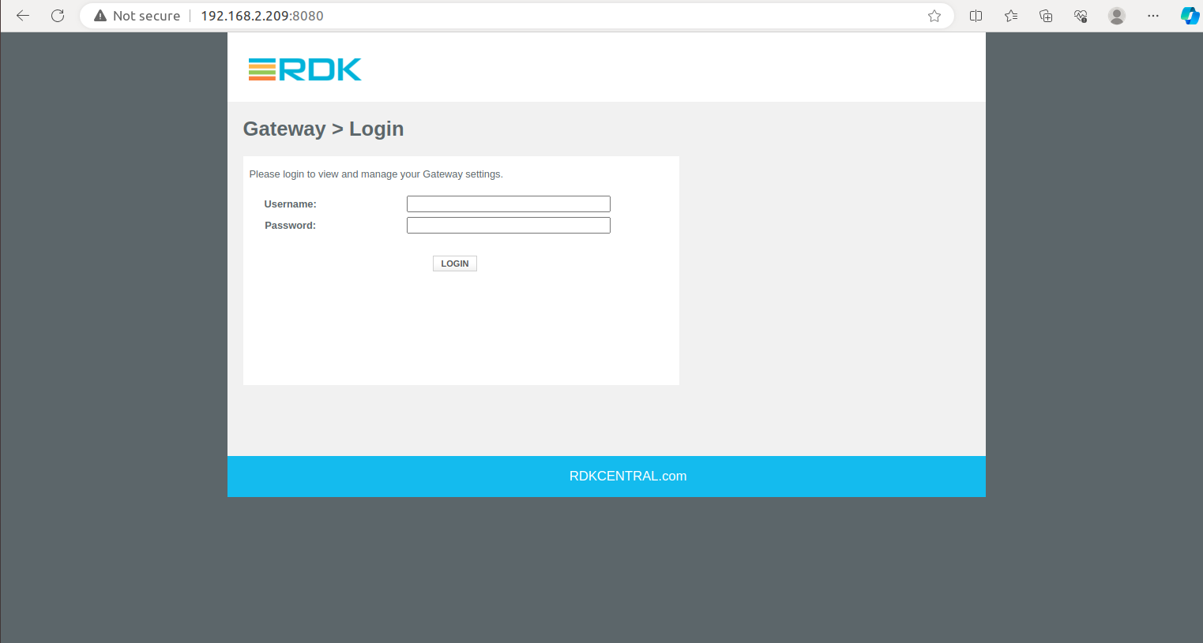
WiFi Status
root@RaspberryPi-Gateway:~# brctl show
bridge name bridge id STP enabled interfaces
br0 8000.000000000000 no
br106 8000.000000000000 no
br403 8000.000000000000 no
brebhaul 8000.000000000000 no
brlan0 8000.00e04e6b71e0 no eth1
wlan0
wlan1
root@RaspberryPi-Gateway:~# iw dev
phy#2
Interface wlan2
ifindex 19
wdev 0x200000001
addr 1e:61:b4:36:d6:ed
type managed
txpower 12.00 dBm
phy#1
Interface wlan1
ifindex 18
wdev 0x100000001
addr 1c:61:b4:36:d6:ed
ssid RPI_RDKB-AP1
type AP
txpower 12.00 dBm
phy#0
Interface wlan0
ifindex 17
wdev 0x1
addr e4:5f:01:d5:3c:11
ssid RPI_RDKB-AP0
type AP
channel 1 (2412 MHz), width: 20 MHz, center1: 2412 MHz
txpower 31.00 dBm
Captive Portal
