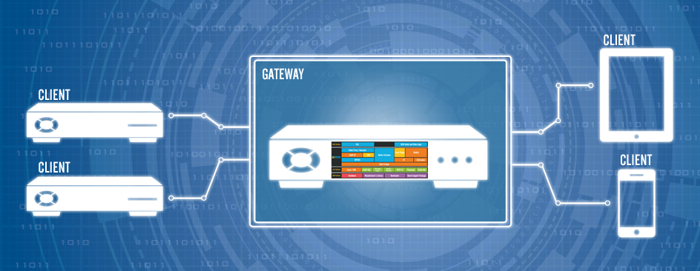
Hardware Development Platform
USER GUIDE
TABLE OF CONTENTS
TABLE OF FIGURES 2
LIST OF TABLES 2
1 Introduction 3
2 Purpose 3
3 Required Equipment 3
4 System Set-up 4
5 RDK-B CONFIGURATION 5
5.1 Image Flashing 5
5.2 Basic Configuration 6
6 WebUI 7
6.1 Login 7
7 Internet Access - LAN clients 9

TABLE OF FIGURES
No table of figures entries found.

LIST OF TABLES
No table of figures entries found.

Introduction
Raspberry Pi series are low cost credit card sized single board computers. The Raspberry Pi models feature a Broadcom SoC that includes an ARM CPU and an on chip graphics-processing unit (GPU). Raspberry Pi uses SD card that facilitates users to swap out different versions of the operating system or software updates, hence, speeding the development and testing process. This is a great way to develop new applications/software and show these to customers in remote locations or at trade shows.
The RDK-B gateway stack runs on the Raspberry Pi 2 and 3 devices and provides all the features of gateway.
Please contact us at info@RDKcentral.com for more information.

Purpose
This document contains set-up and other information to run the RDK-B gateway stack on a Raspberry Pi 2 and Raspberry Pi 3 devices.

Required Equipment
The equipment listed below is required for complete functionality of the standalone environment. The only devices that are tested to work properly in this solution are the specific brands and models listed below. Support for other types of equipment is not available at this time.
Raspberry Pi 2 or Raspberry Pi 3 device
Standard USB keyboard
Television set/monitor with HDMI input.
Ethernet cables
USB-Ethernet Adapter
SD Card

System Set-up

Raspberry Pi
USB
Keyboard
Client
Machine
LAN
USB
TV/Monitor
USB-Ethernet Adapter
HDMI
ETH
WAN
Power

- Connect TV/Monitor to HDMI Video Output.
- Connect Ethernet cable to ETH port.
  - The other end of the Ethernet cable should be connected to the network where DHCP server is running so that the Raspberry Pi device gets assigned an IP address on boot-up.
  - Connectivity to Internet is required so that the client connected can access the internet via RDK-B gateway.
- Connect USB-Ethernet adapter to one of the USB slots present in Raspberry Pi.
- Connect Ethernet cable from USB-Ethernet adapter to the client device/machine.
- Insert the SD card into Micro SD Card Slot.
- Connect Power cable to Micro USB power Input.

.

RDK-B CONFIGURATION

Image Flashing
- Linux:
- Insert an SD card in either the SD card port of the laptop or the USB SD card reader.
- Verify that the SD card has been detected by executing either of the commands listed below:
  - # lsblk
  - # sudo fdisk –l
Notes: Remember to look at the size of the device to be sure that you have identified the device number associated with your SD card. We use “dd” command to write the generated image on the SD card, thus an incorrect identification may delete data from your hard drive or other device of importance. In most case, the hard disk drive will be at /dev/sda.

- Type the following command to ensure that the partitions, if present, on the SD card are not mounted
  - # mount

- Repeat the below command to unmount all the mounted partition present on the SD card.
  - # unmount <partition-mountpoint>

- Execute the following command to flash the image on the SD card
  - # sudo dd if=<r-pi sdimg> of=<SD card device> bs=1M

for ex:
# sudo dd if=rdk-mc-rpi.sdimg of=/dev/sdb bs=1M

- Repeat the below command to unmount all the mounted partition present on the SD card.
  - # unmount <partition-mountpoint>

- Remove the SD card and insert it to the Raspberry Pi SD card slot

- Mac
- Follow the instructions provided in the link below to flash the image:
https://www.raspberrypi.org/documentation/installation/installing-images/mac.md

- Windows
- Follow the instructions provided in the link below to flash the image:
https://www.raspberrypi.org/documentation/installation/installing-images/windows.md

Basic Configuration
- Insert the micro SD card with the flashed RDK-B image in the SD card slot of Raspberry Pi.
- Plug in the power cable to boot up the Raspberry Pi device
- Type “root” when the login prompt is displayed
- Run following in the terminal
# ifconfig
Check the interface shown for USB-Ethernet adapter
e.g eth1, eth2 … so on

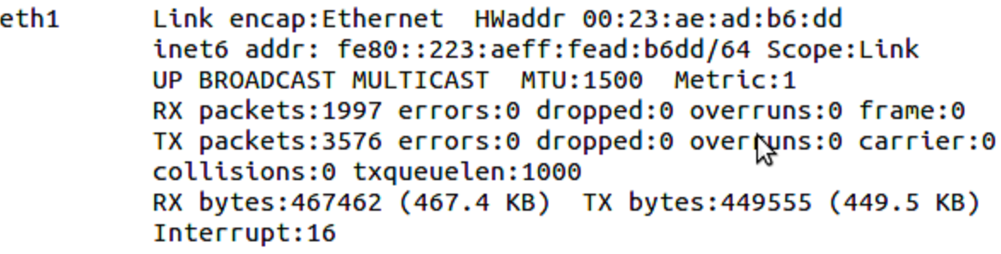

- In case you are running in Ethernet mode, add interface of USB-Ethernet adapter in file “/etc/utopia/system_defaults. Change lan_ethernet_physical_ifnames. It will be your lan side.
e.g: lan_ethernet_physical_ifnames=eth1

- Reboot the Raspberry Pi.

WebUI

Login
- WebUi can be accessed by both the Lan clients and from the WAN Side.
For Lan Clients:
- Open an internet browser on the Lan client/machine.
- Give the following url in the browser window:
From LAN Side:
http://10.0.0.1
From WAN Side:
http://<WAN IP Address of RaspberryPi>:8080
For e.g
http://10.213.51.122:8080
- Login page opens as shown in figure1 below.

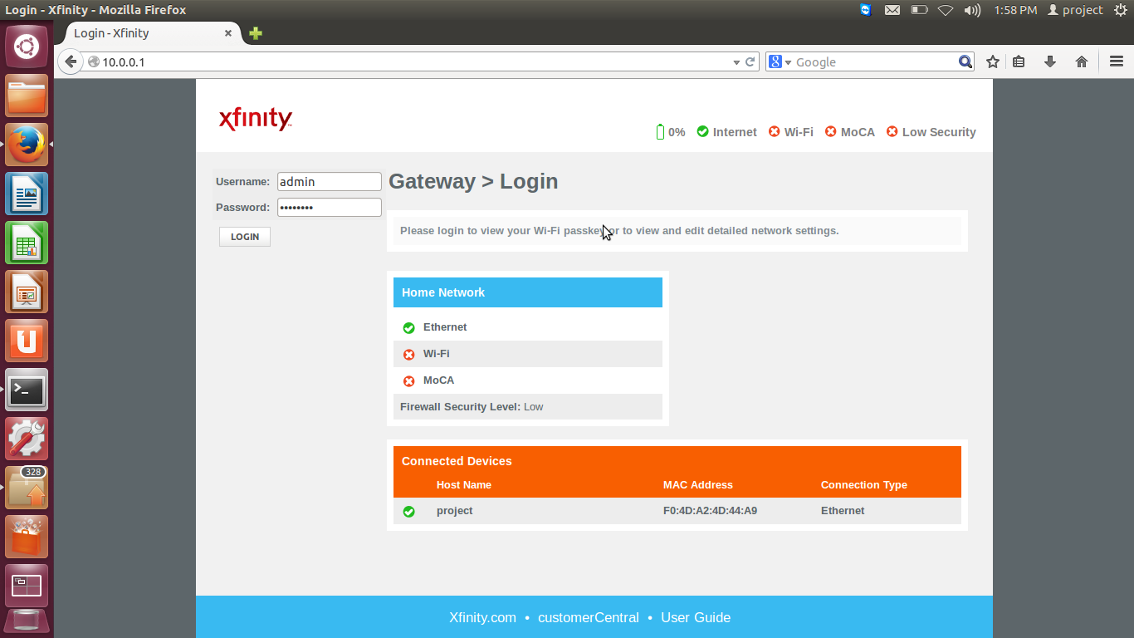
Figure 1: Login - Xfinity
- Enter Credentials:
Username: admin
Password: password

- Figure 2 will open as shown below

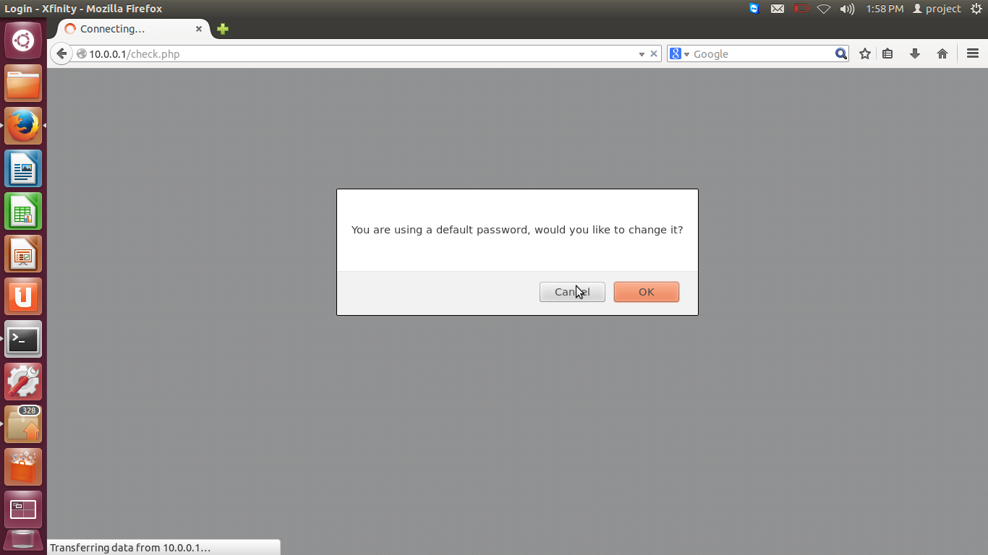
Figure 2
- Press the cancel tab, Figure 3 will open as shown below.
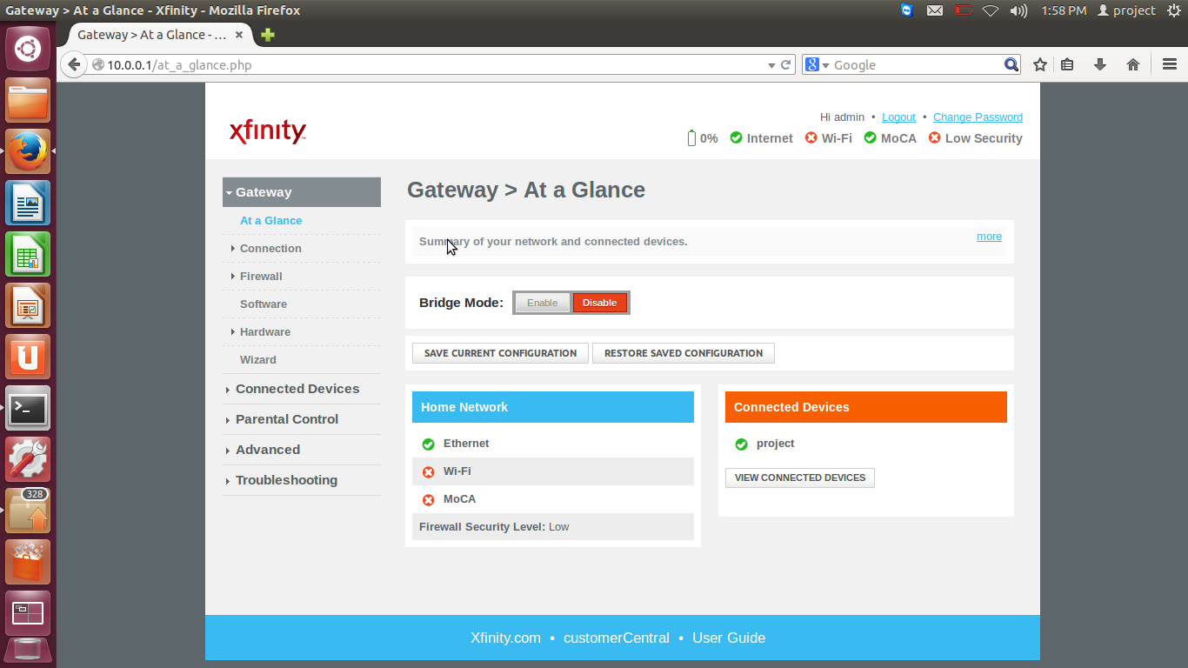
Figure 3: Xfinity

Internet Access - LAN clients
- Lan clients can access the internet through RDK-B gateway.
- Open an internet browser on the Lan client/machine.
- Give the url in the browser window.
For e.g.
www.google.com
- Internet will be accessed as shown below in figure 4:

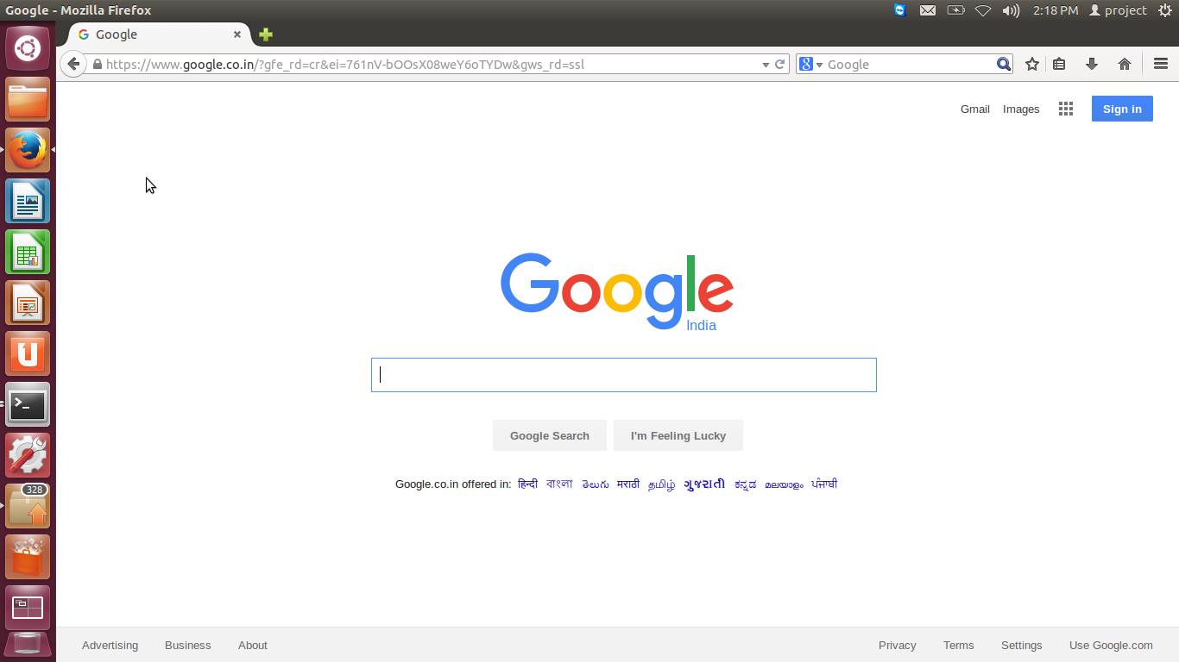
Figure 4: Internet Page

