RDKB RPI4 64b Kirkstone GW Build Sanity Test Results

- Flashed GW 64b kirkstone build in rpi4
- Goto RG console

Summary Table
S.No | Sanity tested on | Status
1 | erouter0 interface got Wan IP | Pass
2 | brlan0 interface got default LAN IP | Pass
3 | Able to take SSH Connection | Pass
4 | All CCSP process are running | Pass
5 | Able to Ping www.google.com | Pass
6 | All systemd services are running | Pass
7 | Able to connect wireless client | Pass
8 | Wireless client got IP from default pool range | Pass
9 | Wireless client can access the CaptivePortal Page | Pass
10 | Internet should work on Connected clients after changing the default credentials | Pass
11 | Using dmcli to check the CCSP TR-181 DataModels | Pass
12 | WebUI page should be loaded on Connected clients after changing the default credentials | Pass
13 | WebUI page should be loaded through erouter0IP via RM | Pass
14 | wlan0 and wlan1 interfaces should be UP and RUNNING | Pass
15 | All ccsp logs files should be generated in /rdklogs/logs folder | Pass
16 | Lan clients should be connected and receive internet | Pass

erouter0 IPv4 address
erouter0 should have valid IP based on the wan configuration .
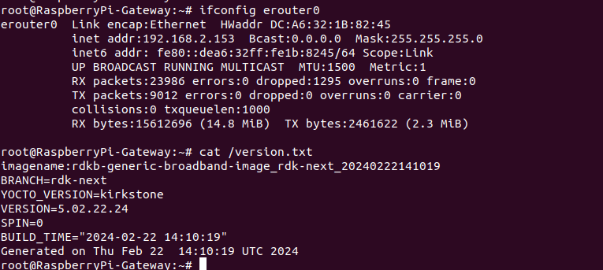
brlan0 IPv4 address
brlan0 IPv4 should be 10.0.0.1 ( i,e Default IP Address )

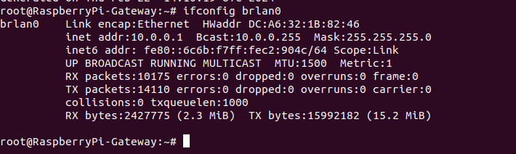
Able to take SSH from WAN IP
ssh from WAN to erouter0 IP should be successful
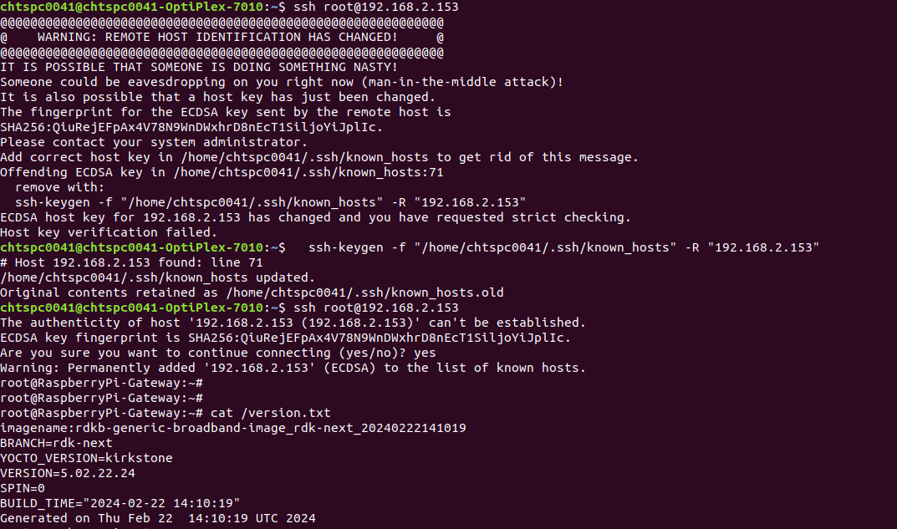

Internet Testing on RPI
- erouter0 Interface should have Ipv4 Address
- verify the ping www.google.com on RPI
- RPI shouldn't lose the Internet
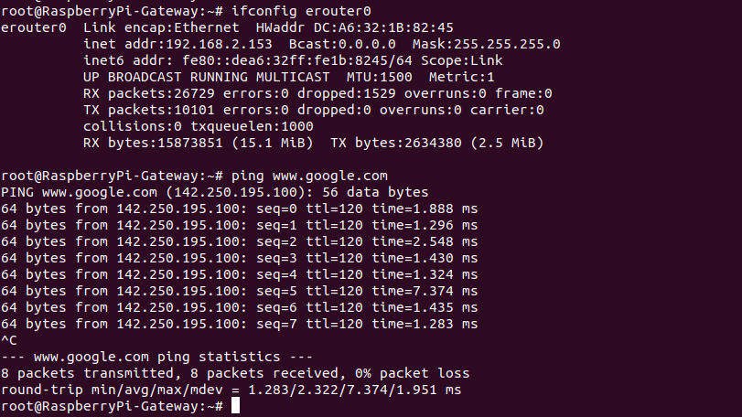
CCSP Process Status
All ccsp process should be Up and corresponding DataModel parameters should be loaded properly.
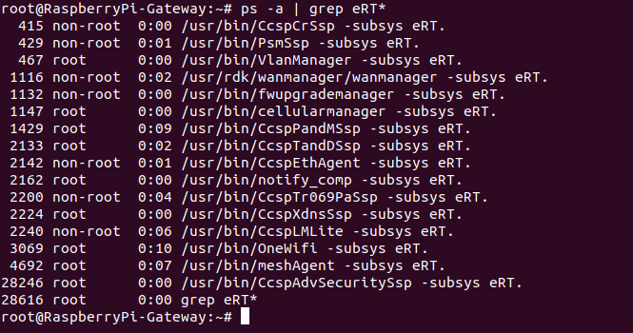
Logs
All ccsp logs will be generated in /rdklogs/logs folder

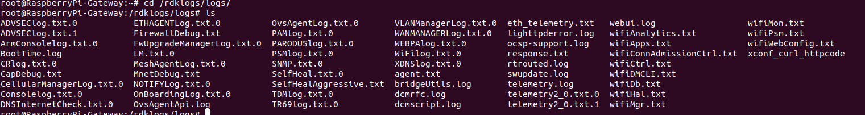
Systemd Status
root@RaspberryPi-Gateway:~# systemctl status
● RaspberryPi-Gateway
State: degraded
Jobs: 1 queued
Failed: 2 units
Since: Thu 1970-01-01 00:00:03 UTC; 54 years 1 month ago
CGroup: /
├─init.scope
│ └─ 1 /sbin/init
└─system.slice
├─CcspAdvSecuritySsp.service
│ └─ 29457 sleep 30
├─CcspCrSsp.service
│ └─ 415 /usr/bin/CcspCrSsp -subsys eRT.
├─CcspEthAgent.service
│ └─ 2142 /usr/bin/CcspEthAgent -subsys eRT.
├─CcspLMLite.service
│ └─ 2240 /usr/bin/CcspLMLite -subsys eRT.
├─CcspPandMSsp.service
│ └─ 1429 /usr/bin/CcspPandMSsp -subsys eRT.
├─CcspTandDSsp.service
│ ├─ 2133 /usr/bin/CcspTandDSsp -subsys eRT.
│ ├─ 2471 /bin/sh /usr/ccsp/tad/self_heal_connectivity_test.sh
│ ├─ 2475 /bin/sh /usr/ccsp/tad/resource_monitor.sh
│ ├─ 2655 sleep 2615
│ └─ 2725 sleep 900
├─CcspTelemetry.service
│ └─ 2885 /usr/bin/telemetry2_0
├─CcspTr069PaSsp.service
│ └─ 2200 /usr/bin/CcspTr069PaSsp -subsys eRT.
├─CcspWebUI.service
│ ├─ 2137 /bin/sh /lib/rdk/brlan0_check.sh
│ ├─ 4421 lighttpd -f /etc/lighttpd.conf
│ └─ 30055 sleep 10
├─CcspXdnsSsp.service
│ └─ 2224 /usr/bin/CcspXdnsSsp -subsys eRT.
├─OvsAgent.service
│ └─ 532 /usr/bin/OvsAgent
├─OvsAgent_ovsdb-server.service
│ ├─ 490 "ovsdb-server: monitoring pid 491 (healthy)"
│ ├─ 491 /usr/sbin/ovsdb-server --remote=punix:/var/run/openvswitch/db.sock --remote=db:Open_vSwitch,Open_vSwitch,manager_options --private-key=db:Open_vSwitch,SSL,private_key --certificate=db:Open_vSwitch,SSL,certificate --ca-cert=db:Open_vSwitch,SSL,ca_cert --pidfile=/var/run/openvswitch/ovsdb-server.pid --detach --monitor --log-file=/dev/null --unixctl=/var/run/openvswitch/ovsdb-server.ctl /tmp/etc/openvswitch/opensync_conf.db /tmp/etc/openvswitch/rdkb-wifi.db
│ └─ 505 ovs-vswitchd --pidfile=/var/run/openvswitch/ovs-vswitchd.pid --log-file=/dev/null --detach
├─PsmSsp.service
│ └─ 429 /usr/bin/PsmSsp -subsys eRT.
├─RdkCellularManager.service
│ └─ 1147 /usr/bin/cellularmanager -subsys eRT.
├─RdkFwUpgradeManager.service
│ └─ 1132 /usr/bin/fwupgrademanager -subsys eRT.
├─RdkVlanManager.service
│ └─ 467 /usr/bin/VlanManager -subsys eRT.
├─RdkWanManager.service
│ ├─ 1116 /usr/rdk/wanmanager/wanmanager -subsys eRT.
│ ├─ 1477 netmonitor
│ └─ 3631 udhcpc -i erouter0 -p /tmp/udhcpc.erouter0.pid -s /etc/udhcpc.script
├─busybox-klogd.service
│ └─ 250 /sbin/klogd -n
├─busybox-syslog.service
│ └─ 251 /sbin/syslogd -n
├─dsm.service
│ └─ 397 /usr/bin/dsm
├─meshAgent.service
│ └─ 4692 /usr/bin/meshAgent -subsys eRT.
├─notifyComp.service
│ └─ 2162 /usr/bin/notify_comp -subsys eRT.
├─ntpd.service
│ └─ 2147 /usr/sbin/ntpd -N -p 0.pool.ntp.org -p 1.pool.ntp.org -p 2.pool.ntp.org -p 3.pool.ntp.org
├─onewifi.service
│ └─ 3069 /usr/bin/OneWifi -subsys eRT.
├─rbus.service
│ └─ 286 /usr/bin/rtrouted
├─rbus_log.service
│ ├─ 398 /bin/sh /usr/bin/rbus_log_capture.sh
│ └─ 30119 sleep 10
├─rbus_session_mgr.service
│ └─ 404 /usr/bin/rbus_session_mgr
├─rdkbLogMonitor.service
│ ├─ 1274 /bin/sh /rdklogger/rdkbLogMonitor.sh
│ └─ 28685 sleep 60
├─snmpSubAgent.service
│ └─ 2151 /usr/bin/snmp_subagent "&"
├─snmpd.service
│ └─ 287 /usr/sbin/snmpd -f -C -c /usr/ccsp/snmp/snmpd.conf -M /usr/share/snmp/mibs -Le
├─system-getty.slice
│ └─getty@tty1.service
│ └─ 264 /sbin/agetty -o "-p -- \\u" --noclear - linux
├─system-serial\x2dgetty.slice
│ └─serial-getty@ttyS0.service
│ ├─ 285 /bin/login -f
│ └─ 960 -sh
├─systemd-journald.service
│ └─ 153 /lib/systemd/systemd-journald
├─systemd-udevd.service
│ └─ 176 /lib/systemd/systemd-udevd
├─usp-pa.service
│ └─ 3629 /usr/bin/UspPa -v1 --resetfile /etc/usp-pa/usp_factory_reset.conf --truststore /etc/usp-pa/usp_truststore.pem --interface erouter0 --log syslog --dbfile /nvram/usp-pa.db
├─utopia.service
│ ├─ 349 klogd -c 6
│ ├─ 352 syslogd -l 6
│ ├─ 379 syseventd
│ ├─ 395 /usr/bin/syseventd_fork_helper 12
│ ├─ 861 crond -l 9
│ ├─ 1056 trigger
│ ├─ 1124 dropbear -R -E -a -r /tmp/.dropbear/dropcfg1974 -r /tmp/.dropbear/dropcfg2974 -p "[]:22" -P /var/run/dropbear.pid -B
│ ├─ 1663 IGD brlan0
│ ├─ 3673 nfq_handler 4
│ ├─ 8127 dropbear -R -E -a -r /tmp/.dropbear/dropcfg1974 -r /tmp/.dropbear/dropcfg2974 -p "[]:22" -P /var/run/dropbear.pid -B
│ ├─ 8133 -sh
│ ├─ 13481 dnsmasq -P 4096 -C /var/dnsmasq.conf
│ ├─ 13553 zebra -d -f /var/zebra.conf -P 0
│ ├─ 30130 systemctl status
│ └─ 30131 /bin/cat
└─webpabroadband.service
└─ 3167 /usr/bin/webpa "&"
WebUI Test on RPI
WebUI should be loaded in Webbrowser by using erouter0 IPv4 Address(i,e erouter0ip:80) and login should be successful
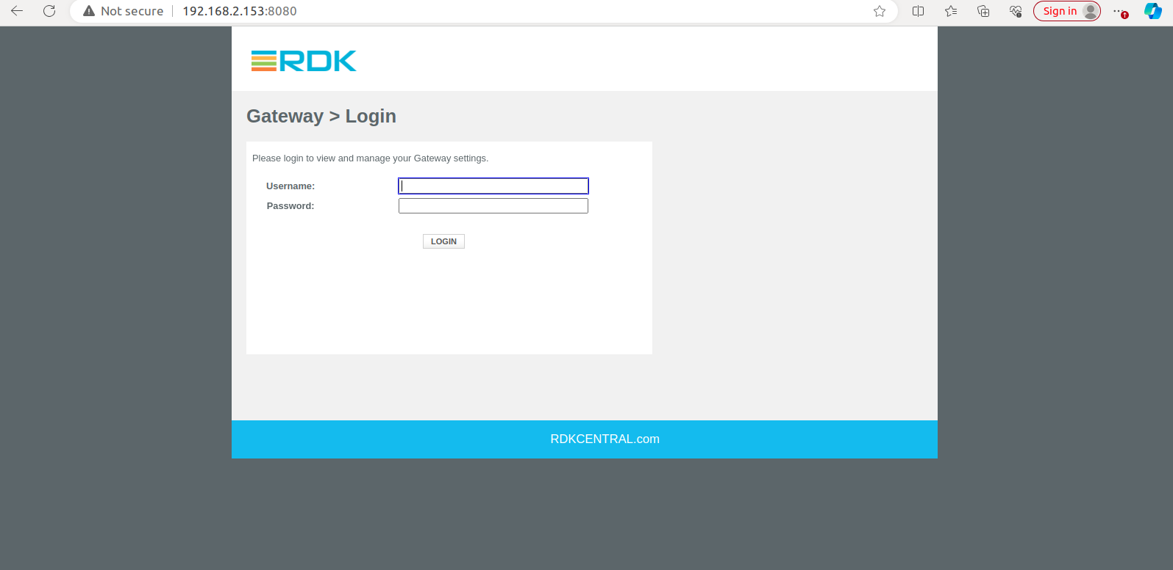
WiFi Status
root@RaspberryPi-Gateway:~# brctl show
bridge name bridge id STP enabled interfaces
br0 8000.000000000000 no
br106 8000.000000000000 no
br403 8000.000000000000 no
brebhaul 8000.000000000000 no
root@RaspberryPi-Gateway:~# ovs-vsctl show
7682791e-6ca5-482f-9441-929821c2b74b
Bridge brlan0
Port eth1
Interface eth1
Port brlan0
Interface brlan0
type: internal
Port wlan0
Interface wlan0
Port wlan1
Interface wlan1
root@RaspberryPi-Gateway:~#
root@RaspberryPi-Gateway:~# iw dev
phy#2
Interface wlan2
ifindex 18
wdev 0x200000001
addr 9e:a2:f4:d5:ed:96
type managed
txpower 42949572.96 dBm
phy#1
Interface wlan1
ifindex 17
wdev 0x100000001
addr 9c:a2:f4:d5:ed:96
ssid RPI_RDKB-AP1
type AP
txpower 23.00 dBm
phy#0
Interface wlan0
ifindex 16
wdev 0x1
addr e4:5f:01:f1:08:cf
ssid RPI_RDKB-AP0
type AP
channel 1 (2412 MHz), width: 20 MHz, center1: 2412 MHz
txpower 31.00 dBm

Captive Portal
